Ansible challenge
Create ci pipeline that will deploy and configure these VMs using terraform and ansible according following requirements
- Deploy 2 virtual machines using terraform.
  - first vm on Amazon linux, hostname: c8.local
  - second vm on ubuntu 21.04, hostname: u21.local
Step 1: Create the project directory
On your Terraform control machine, run:
mkdir -p ansible-challenge/terraform
cd ansible-challenge/terraform 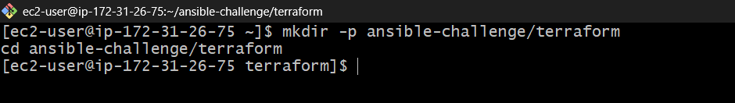
Step 2: Check prerequisites
Run these commands:
terraform -version
aws --version
aws sts get-caller-identity 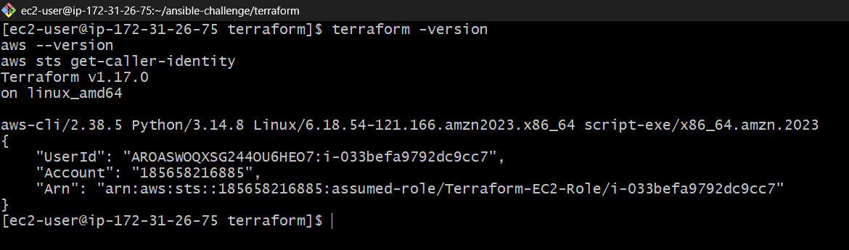
Step 3: Create main.tf
We'll use Amazon Linux 2023 for c8.local and Ubuntu 21.04 for u21.local if an appropriate AMI is available.
Important: Ubuntu 21.04 is end-of-life, so a current public AMI may not be available in your region. We will check this rather than silently substituting another Ubuntu version.
Create the file:
nano main.tf
provider "aws" {
region = "us-east-1"
}

# Amazon Linux VM
resource "aws_instance" "frontend" {
ami = "ami-08c46876c64a927b8"
instance_type = "t3.micro"
key_name = "linux-key"

tags = {
Name = "c8.local"
}
}

# Ubuntu VM
resource "aws_instance" "backend" {
ami = "ami-0d97d7f07b25dd693"
instance_type = "t3.micro"
key_name = "linux-key"

tags = {
Name = "u21.local"
}
}

output "frontend_ip" {
value = aws_instance.frontend.public_ip
}

output "backend_ip" {
value = aws_instance.backend.public_ip
}

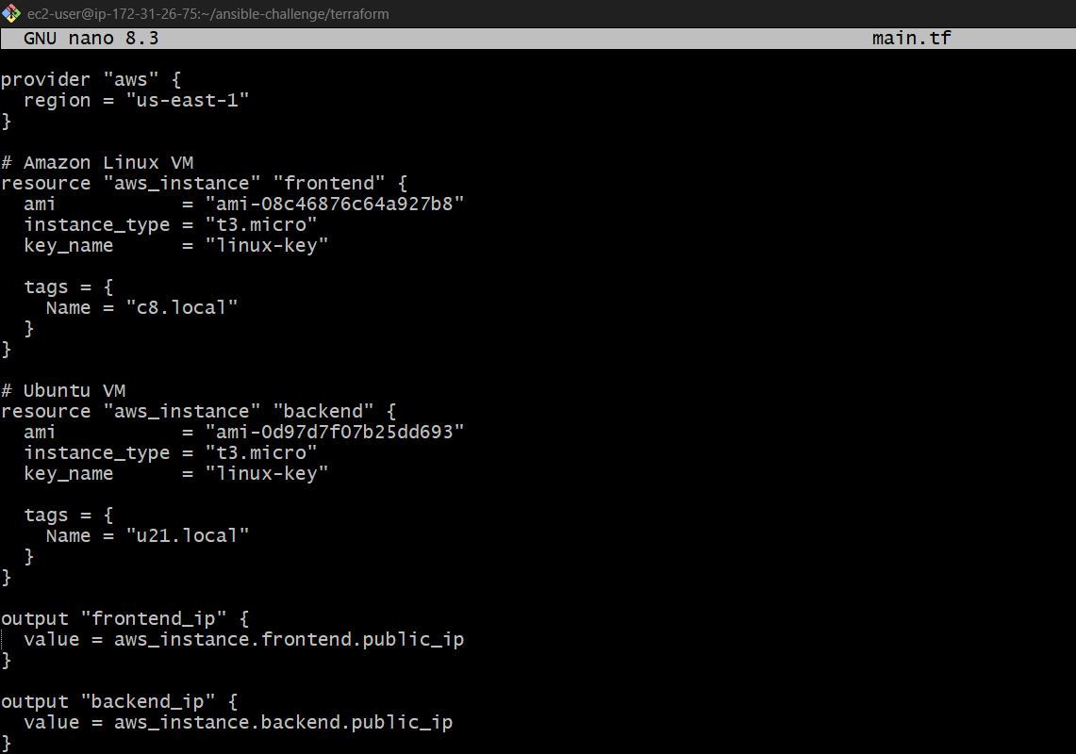

Step 4: Initialize Terraform
terraform init 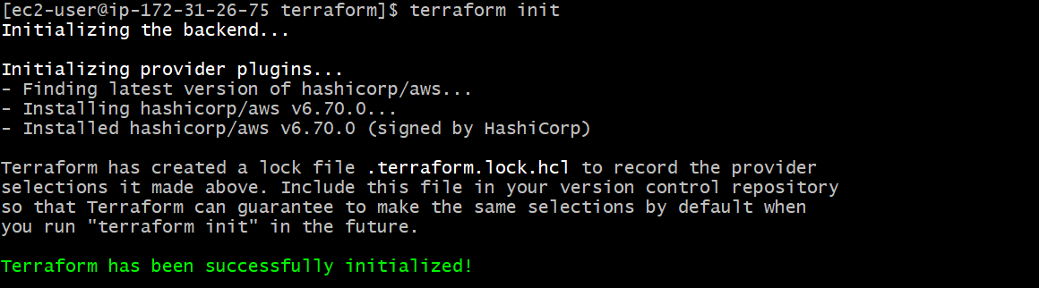
Then validate the configuration:
terraform validate
terraform plan 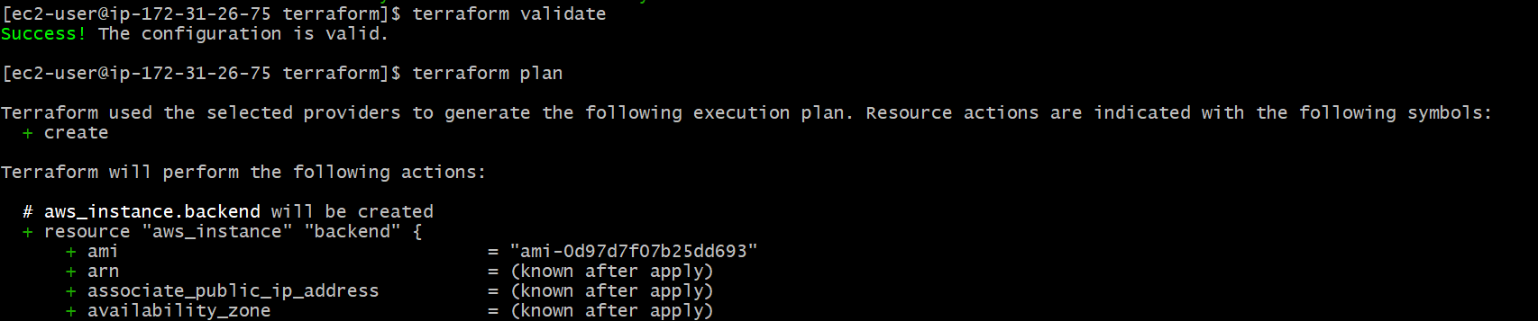
Step 5: Check the Ubuntu 21.04 AMI
Objective: Verify that both AMI IDs are valid and Terraform can plan to create the two EC2 instances.
Purpose: Ubuntu 21.04 is discontinued, so we need to confirm that the AMI you provided is still available in us-east-1 before deploying.
Run: terraform plan
Step 6: Deploy the VMs
Objective: Create both EC2 instances using Terraform.
Purpose: Provision the frontend and backend servers for the next Ansible configuration stage.
Only after Step 5 succeeds, run:
terraform apply
. 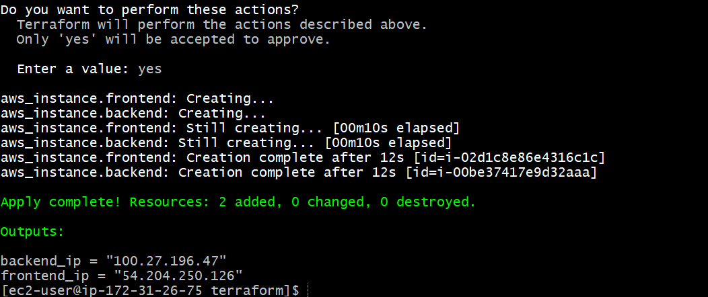

- As a result of terraform execution, dynamically create inventory for ansible
c8.local should be in the frontend group
u21.local should be in the backend group
Objective: After Terraform creates the two EC2 instances, automatically generate an Ansible inventory with these groups:
We'll use your existing Terraform project and the EC2 instances you already created.
Step 1: Check your Terraform outputs
On your Terraform control machine (ec2-user), navigate to your Terraform project directory and run:
cd /home/ec2-user/ansible-challenge/terraform
pwd
ls -la
terraform state list 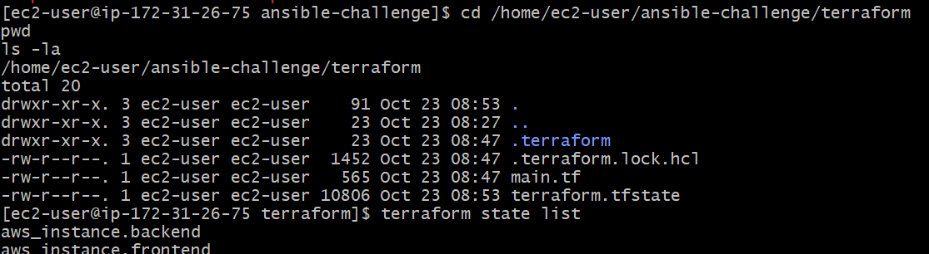

terraform output
You should see the IP addresses of your frontend and backend instances.
terraform output -raw frontend_ip
terraform output -raw backend_ip 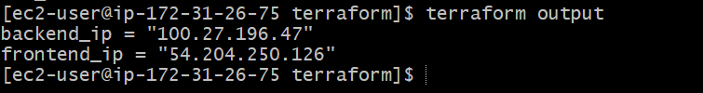
Step 2: Create a dynamic inventory template
Create a file named inventory.tftpl in the same directory as main.tf.
vi inventory.tftpl
Add this content:
[frontend]
c8.local ansible_host=${frontend_ip} ansible_user=ec2-user

[backend]
u21.local ansible_host=${backend_ip} ansible_user=ubuntu
Save and exit with Esc, :wq, and Enter. 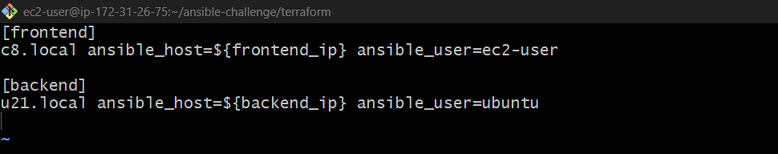
Step 3: Update main.tf
Add the following resource to your existing main.tf.
resource "local_file" "ansible_inventory" {
content = templatefile("${path.module}/inventory.tftpl", {
frontend_ip = aws_instance.frontend.public_ip
backend_ip = aws_instance.backend.public_ip
})

filename = "${path.module}/inventory"
} 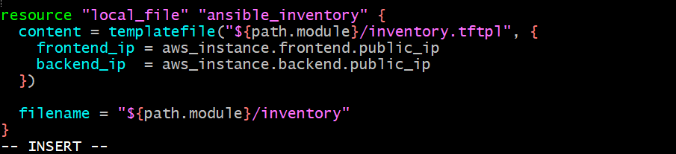
This uses the EC2 public IP addresses from Terraform and generates an Ansible inventory file automatically.
Step 4: Add the local provider
Check whether your existing main.tf already declares the local provider. If it doesn't, add it inside your existing terraform.required_providers block:
local = {
source = "hashicorp/local"
version = "~> 2.5"
}
Keep your existing AWS provider configuration.
Step 5: Apply Terraform
Run:
terraform init 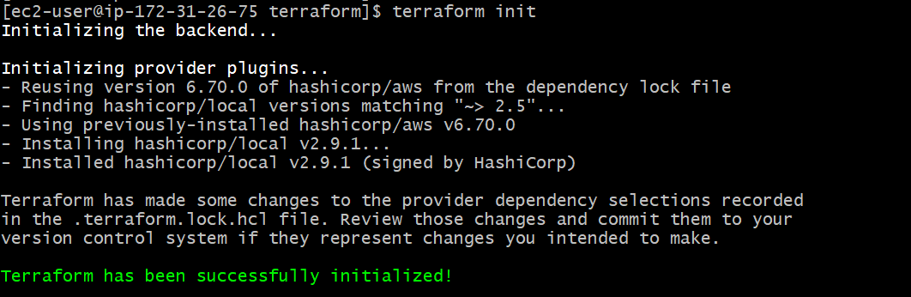
terraform plan 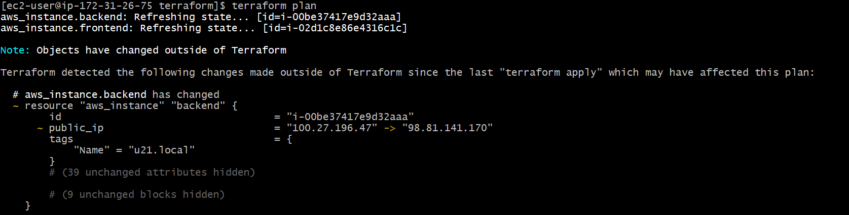
terraform apply
Enter yes when prompted.
Terraform will create or update the inventory file after resolving the EC2 instance IP addresses. 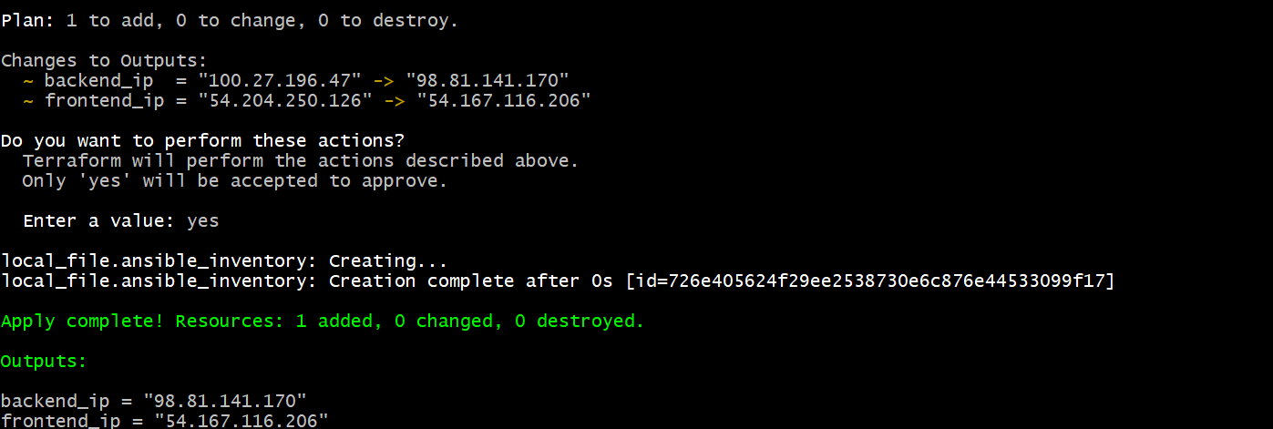
Step 6: Verify the generated inventory
cat inventory
Expected format (using your actual IP addresses):
[frontend]
c8.local ansible_host=54.204.250.126 ansible_user=ec2-user

[backend]
u21.local ansible_host=100.27.196.47 ansible_user=ubuntu
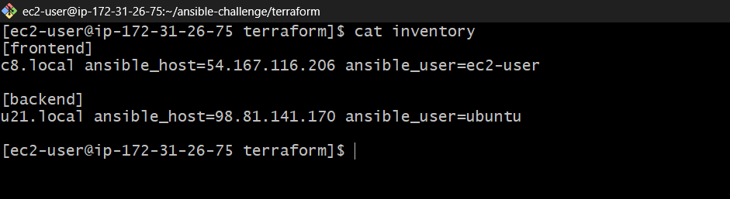
The IPs above reflect your earlier Terraform outputs; verify them against the latest output.
Step 7: Test Ansible inventory
Run:
ansible-inventory -i inventory --list 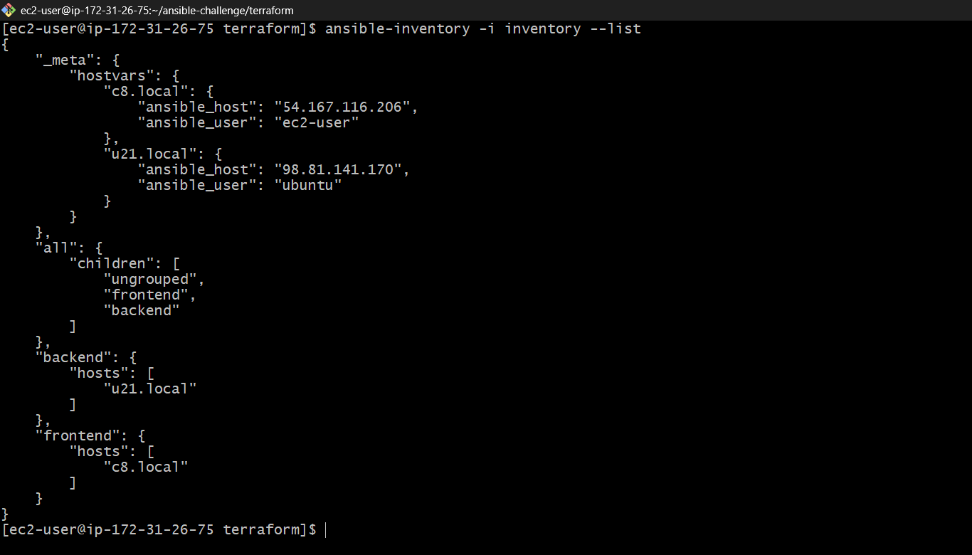
To check the groups:
ansible-inventory -i inventory --graph 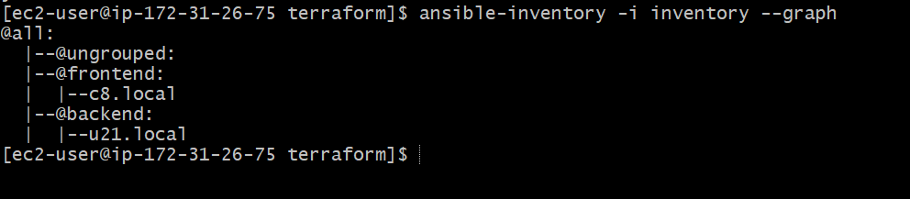

Task 2 is complete when Terraform generates the inventory file and Ansible recognizes both groups.
Note: This creates a Terraform-generated inventory file using the EC2 public IPs. If your Ansible control machine connects using private IPs instead, change public_ip to private_ip in the resource.

- Create ansible playbook for c8.local and u21.local
- for linux OS playbook should apply the following changes
  - selinux: disable
  - firewalld: disable
- for frontend playbook group should install and configure nginx
  - nginx configuration should do proxying from port 80 on port 19999 to the
  - backend group
- for the backend group, the playbook must install the Netdata application from the
  - official repositories and run it on port 19999.
Expected architecture
Client / Browser
HTTP port 80
Frontend — c8.local
Amazon Linux · Nginx
Reverse proxy: port 80 → backend:19999
Backend — u21.local
Ubuntu · Netdata
Monitoring dashboard on port 19999
We'll also configure SELinux and firewalld on the Amazon Linux host, and ensure the Ubuntu backend has its firewall disabled if UFW is installed and active.

Step 1: Create the playbook
On your Terraform/Ansible control machine, run:
cd /home/ec2-user/ansible-challenge/terraform
vi setup.yml
Paste this complete playbook.

---
- name: Configure Linux security settings
hosts: all
become: true

tasks:
- name: Disable SELinux persistently on Amazon Linux
ansible.builtin.lineinfile:
path: /etc/selinux/config
regexp: '^SELINUX='
line: 'SELINUX=disabled'
when: ansible_os_family == "RedHat"

- name: Set SELinux to permissive immediately
ansible.builtin.command: setenforce 0
when: ansible_os_family == "RedHat"
failed_when: false
changed_when: false

- name: Stop and disable firewalld if installed
ansible.builtin.shell: |
if systemctl list-unit-files firewalld.service --no-legend | grep -q firewalld; then
systemctl disable --now firewalld
fi
args:
executable: /bin/bash
when: ansible_os_family == "RedHat"
changed_when: false

- name: Disable UFW on Ubuntu if installed
ansible.builtin.command: ufw disable
when: ansible_os_family == "Debian"
failed_when: false
changed_when: false

- name: Install and configure Netdata on backend
hosts: backend
become: true

tasks:
- name: Install required download tools on Ubuntu
ansible.builtin.apt:
name:
- curl
- wget
- ca-certificates
state: present
update_cache: true

- name: Download official Netdata installer
ansible.builtin.get_url:
url: https://my-netdata.io/kickstart.sh
dest: /tmp/netdata-kickstart.sh
mode: '0755'

- name: Install Netdata using its official installer
ansible.builtin.command:
cmd: /bin/sh /tmp/netdata-kickstart.sh --non-interactive
creates: /usr/sbin/netdata

- name: Enable and start Netdata
ansible.builtin.systemd:
name: netdata
enabled: true
state: started

- name: Install and configure Nginx on frontend
hosts: frontend
become: true

tasks:
- name: Install Nginx on Amazon Linux
ansible.builtin.dnf:
name: nginx
state: present

- name: Configure Nginx reverse proxy to Netdata
ansible.builtin.copy:
dest: /etc/nginx/conf.d/netdata.conf
mode: '0644'
content: |
server {
listen 80;
server_name _;

location / {
proxy_pass http://{{ hostvars[groups['backend'][0]]['ansible_host'] }}:19999;
proxy_http_version 1.1;
proxy_set_header Host $host;
proxy_set_header X-Real-IP $remote_addr;
proxy_set_header X-Forwarded-For $proxy_add_x_forwarded_for;
proxy_set_header X-Forwarded-Proto $scheme;
proxy_set_header Upgrade $http_upgrade;
proxy_set_header Connection "upgrade";
}
}
notify: Restart Nginx

- name: Enable and start Nginx
ansible.builtin.systemd:
name: nginx
enabled: true
state: started

handlers:
- name: Restart Nginx
ansible.builtin.systemd:
name: nginx
state: restarted
Save and exit with Esc, then :wq, then Enter.
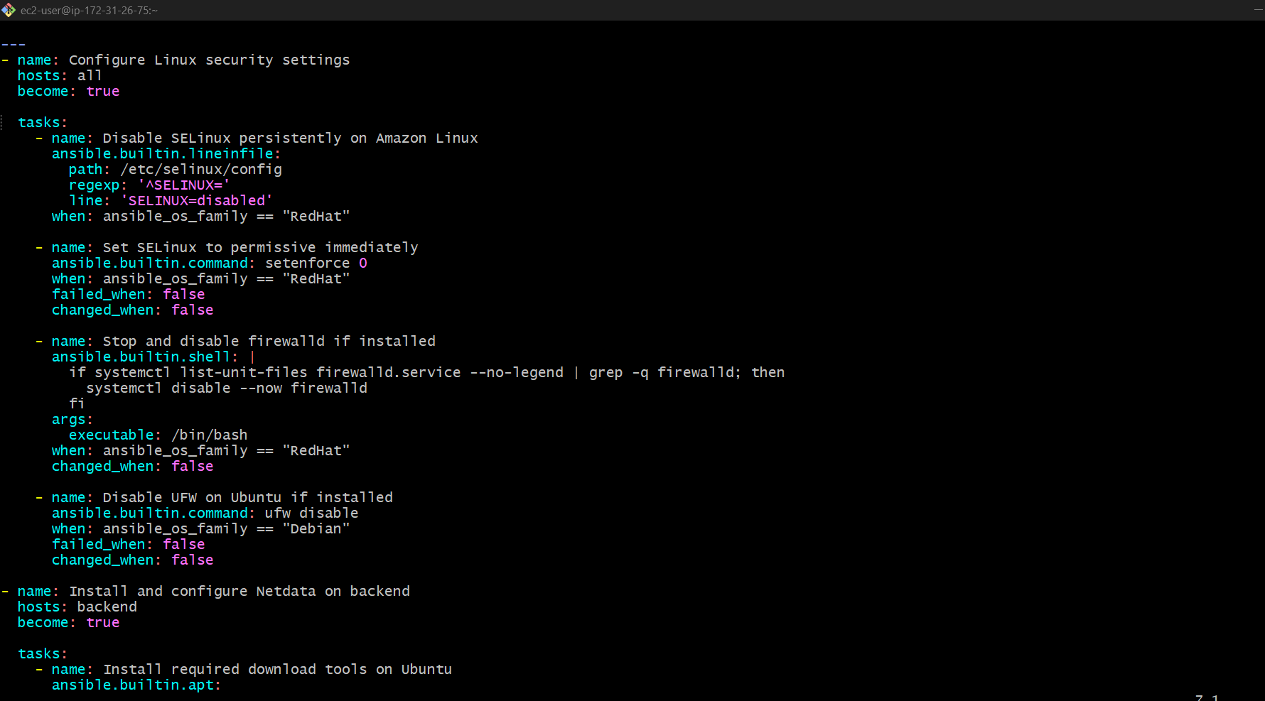
Important notes:
- On Amazon Linux, SELinux is configured to be disabled on the next boot. The playbook sets it to permissive immediately; reboot the host to apply the persistent disabled setting.
- The playbook attempts to disable firewalld on Amazon Linux and UFW on Ubuntu. Security group rules still control network access.
- Netdata is installed using its official kickstart installer. If the binary path differs on your system, the creates check may need adjustment.
Step 2: Check the inventory
ansible-inventory -i inventory --graph
Confirm that frontend contains c8.local and backend contains u21.local. 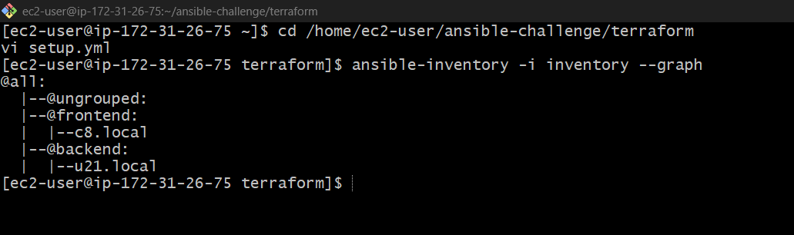
Step 3: Test SSH connectivity
If your private key is at ~/linux-key.pem, run:
chmod 400 ~/linux-key.pem
ansible -i inventory all -m ping --private-key ~/linux-key.pem
Both hosts should return "ping": "pong".
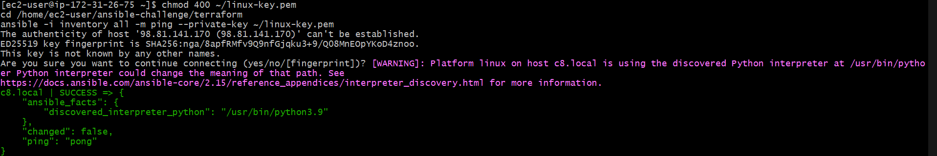
Step 4: Validate the playbook
ansible-playbook -i inventory setup.yml --syntax-check
Then preview the tasks:
ansible-playbook -i inventory setup.yml --list-hosts 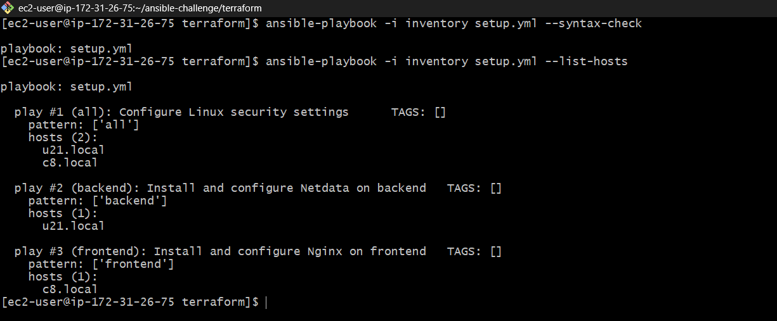

Step 5: Run the playbook
ansible-playbook -i inventory setup.yml --private-key ~/linux-key.pem
If your key is in a different location, replace the path accordingly. 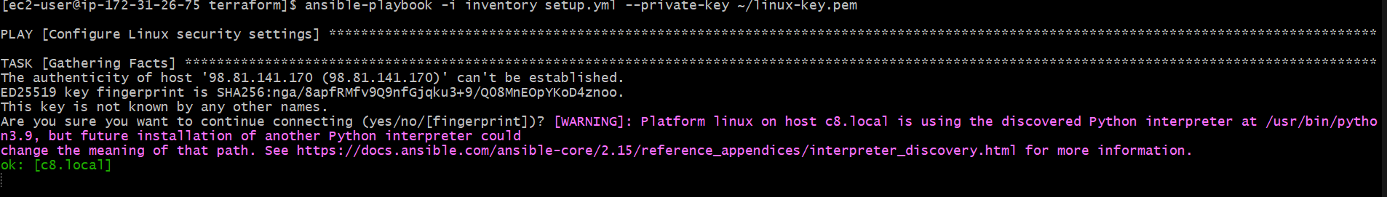
Step 6: Configure AWS security groups
Make sure the EC2 security groups allow:
Port | Source | Purpose
22 | Your control machine's IP | SSH administration
80 | Your permitted client IPs | Access Nginx
19999 | Frontend instance's security group | Frontend-to-backend Netdata traffic
Do not expose port 19999 publicly unless you specifically need direct dashboard access. 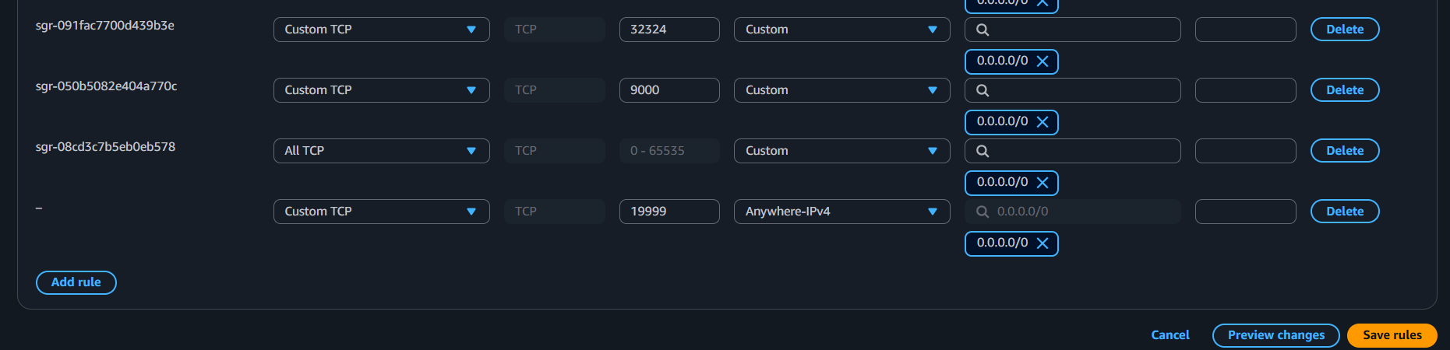

Install Netdata
Step 1: Run this from your Terraform directory:
ansible -i inventory backend -m shell -a "apt-get update && apt-get install -y curl ca-certificates && curl -fsSL https://my-netdata.io/kickstart.sh -o /tmp/netdata-kickstart.sh && sh /tmp/netdata-kickstart.sh --non-interactive" --become --private-key ~/linux-key.pem 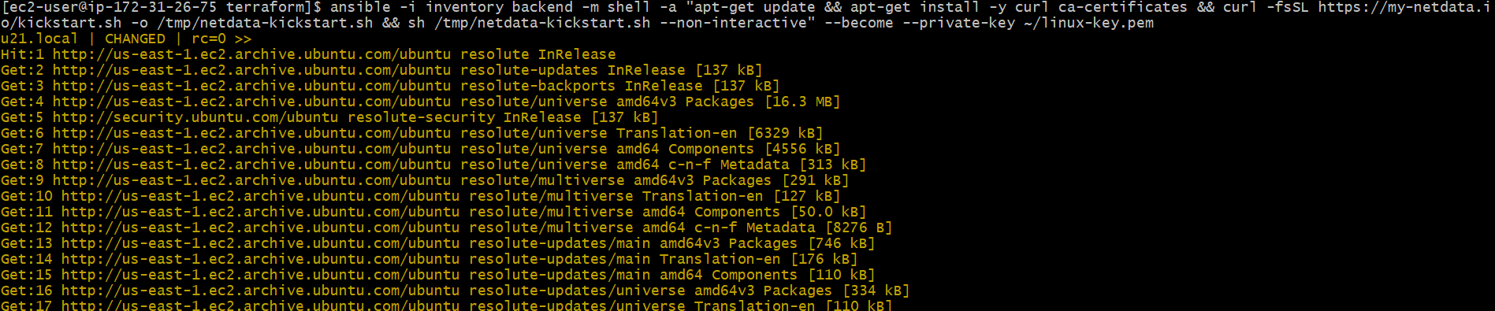
Step 2: Enable and start Netdata
ansible -i inventory backend -m systemd -a "name=netdata state=started enabled=yes" --become --private-key ~/linux-key.pem 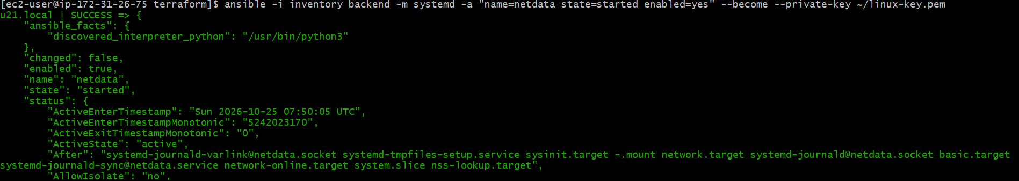
Step 3: Verify the service
ansible -i inventory backend -m command -a "systemctl is-active netdata" --become --private-key ~/linux-key.pem
Step 4: Verify the listening port
ansible -i inventory backend -m shell -a "ss -lntp | grep ':19999'" --become --private-key ~/linux-key.pem
Step 7: Verify the application
Check Netdata directly on the backend:
ansible -i inventory backend -m command -a "systemctl is-active netdata" --become --private-key ~/linux-key.pem
Check Nginx on the frontend:
ansible -i inventory frontend -m command -a "systemctl is-active nginx" --become --private-key ~/linux-key.pem 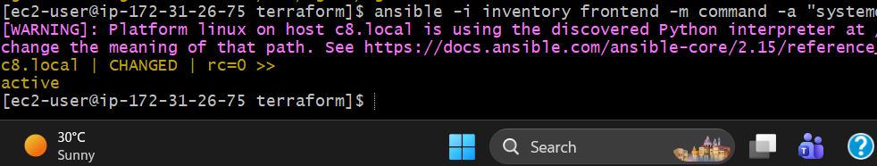
Finally, open this URL in your browser, replacing the IP with the current frontend public IP:
http://54.167.116.206/ 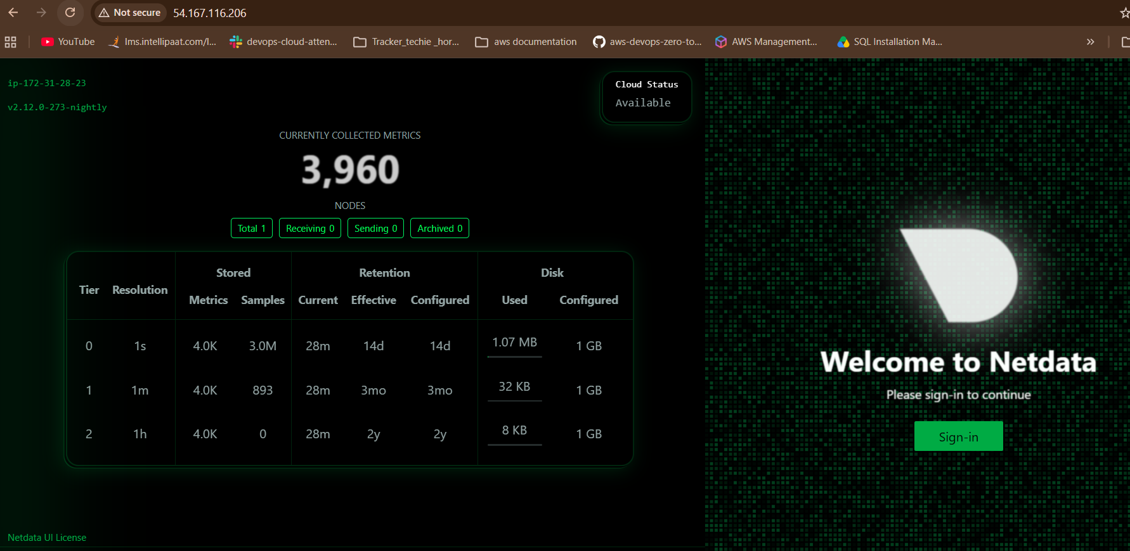
You should see the Netdata dashboard through the Nginx reverse proxy. If it fails, check the security group rules and the Ansible task output first. 